Assignment on Variable/Model Selection

The file "nflcombine2021.csv" contains 2021 NFL combine data. The NFL combine is a yearly event where college football players that are NFL prospects are put through a series of tests. The 2021 NFL combine data (performance and measurement data) are provided for 267 college football players. The columns are as follows: Ht is the player height, Wt is the player weight, yd40 is the player's 40 yard dash time, Vertical is the player's vertical jump, Bench is the number of times 225 can be bench pressed, BroadJump is the player's broad jump, Cone3 is the time it takes the player to complete a particular drill, Shuttle is the time it takes a player to completed a particular drill, and “Draftedyes” indicates if the player was drafted (picked up by a NFL team). The file "znflcombine2021.csv" is the same data only the eight potential predictor variables have been standardized for use with lasso regression. Using the stepwise, random forest importance, and lasso methods of variable selection, determine which of the other eight columns, if any, would be good predictors of Draftedyes. Note: for stepwise and random forests, "nflcombine2021.csv" can be used. For lasso regression, "znflcombine2021.csv" must be used. (There is no need to create dummy variables or to preprocess the data in any other way as long the standardized file is used for lasso regression.)
After variable selection analysis there may not be a perfect consensus between the three methods on variables selected; however, clearly state which variables each method selected and give suggestions for how you would proceed to construct a model (you do not have to build a particular model, just choose the variables that would be used).

# read data in
df <-read.csv("C:/Users/tyler/OneDrive/Documents/GitHub/work_to_show/Classes Spring 2026/BDA Spring 26/Datasets/znflcombine2021.csv", header=TRUE)
head(df)
colnames(df)

# Stepwise Regression using AIC
# install.packages("MASS")
library(MASS)
step_model <- stepAIC(lm(Draftedyes ~ ., data = df), direction = "both", trace = FALSE)
# Print the selected variables
print(step_model$anova)

# What to pick for Stepwise Regression using AIC
Predictors I would pick:
Wt
yd40
Cone3

Stepwise Model Path
Analysis of Deviance Table

Initial Model:
Draftedyes ~ Ht + Wt + yd40 + Vertical + Bench + BroadJump +
Cone3 + Shuttle

Final Model:
Draftedyes ~ Wt + yd40 + Cone3

Step Df Deviance Resid. Df Resid. Dev AIC
1 258 48.26835 -438.6962
2 - Vertical 1 0.06585749 259 48.33420 -440.3322
3 - Shuttle 1 0.10060691 260 48.43481 -441.7770
4 - Ht 1 0.11008586 261 48.54490 -443.1708
5 - Bench 1 0.05452453 262 48.59942 -444.8711
6 - BroadJump 1 0.32655477 263 48.92598 -445.0830

For a regression model to predict Draftedyes I would use the predictors Wt, yd40, Cone3. My model would be "Draftedyes ~ Wt + yd40 + Cone3".

# Random Forest
library(randomForest)
df$Draftedyes<-factor(df$Draftedyes)
RFM=randomForest(Draftedyes ~.,data=df, importance=TRUE)
importance(RFM)
varImpPlot(RFM)

A matrix: 8 × 4 of type dbl
 | 0 | 1 | MeanDecreaseAccuracy | MeanDecreaseGini
Ht | 0.8577694 | 4.757633 | 4.079098 | 10.61858
Wt | 7.1899436 | 6.341123 | 11.131492 | 19.05648
yd40 | 6.3441233 | 10.537335 | 12.980610 | 18.16746
Vertical | 5.5116114 | 2.418433 | 6.838149 | 13.69633
Bench | -1.5117808 | 9.036706 | 5.089367 | 15.55658
BroadJump | 10.2936505 | -2.594324 | 8.071412 | 14.38485
Cone3 | 4.9763782 | 4.756804 | 8.251325 | 17.20850
Shuttle | 6.9825320 | 1.455912 | 7.241367 | 14.59925

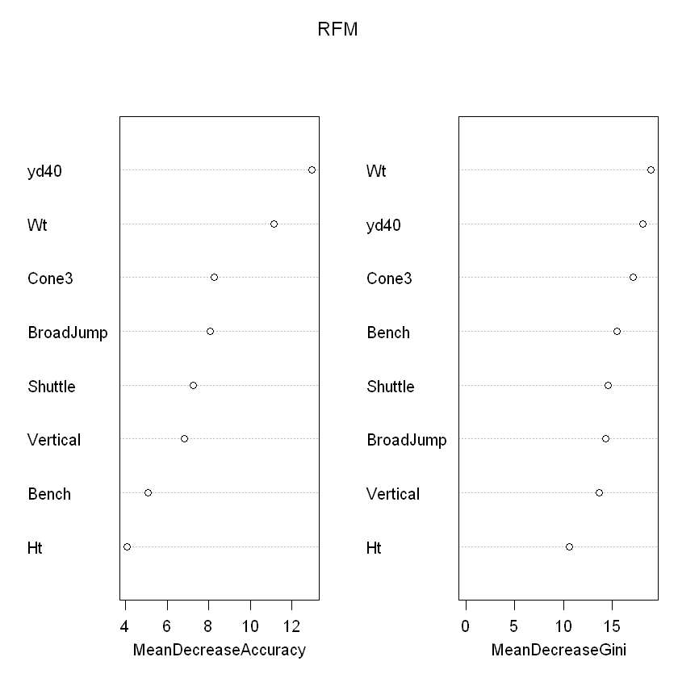
# What to pick for Random Forest
Predictors I would pick:
Wt, yd40, Broadjump, Cone3

For a regression model to predict Draftedyes I would use the predictors Wt, yd40, BroadJump, Cone3. My model would be "Draftedyes ~ Wt + yd40 + BroadJump + Cone3". I chose this because the %IncMSE < 5.

# Lasso Regression
# Note these variables are all on the same scale, so no standardization is needed.
# install.packages("gamlr")
library(gamlr)
modMat<-model.matrix(~Ht + Wt + yd40 + Vertical + Bench + BroadJump +
Cone3 + Shuttle, data=df)
fit<-gamlr(x=modMat,y=df$Draftedyes)
plot(fit)
coef(fit)

10 x 1 sparse Matrix of class "dgCMatrix"
seg72
intercept 1.36329588
(Intercept) .
Ht 0.03816811
Wt 0.26472550
yd40 -0.23852531
Vertical .
Bench 0.03886583
BroadJump 0.05558262
Cone3 -0.03811878
Shuttle -0.03680288

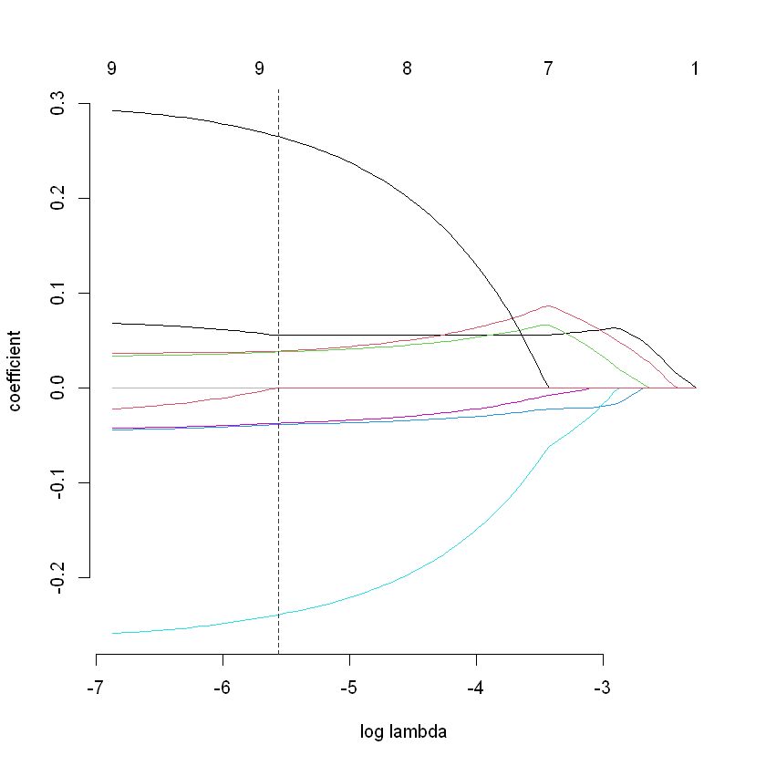

# What to pick for Lasso Regression
Predictors I would pick:
Ht, Wt, yd40, Bench, BroadJump, Cone3, Shuttle.

For a regression model to predict Draftedyes I would use the predictorsHt, Wt, yd40, Bench, BroadJump, Cone3, Shuttle. My model would be "Draftedyes ~ Ht+Wt+yd40+Bench+BroadJump+Cone3+Shuttle.". I chose this because the lasso regression chose these but would not take Vertical.

# Models I would pick
I would choose stepwise model because of landing on 3 predictors. The lasso regression got better as all the other variables got removed. The random forest is the second best in my opinion, based off it being a percentage of it being removed and the increase of MSE%.

